CASE STUDY: ENHANCING FAMILY SAFETY WITH THE FAMILY GUARDIAN APP

1. Project Overview
- Project Name: Family Guardian App
- Client: Herond Labs
- Development Partner: DanaExperts
- Objective: To develop a robust mobile application (iOS & Android) that provides real-time location tracking, emergency alerts, and device monitoring to ensure the safety and connectivity of family members.

2. The Client's Challenge
Herond Labs, a technology company focused on creating impactful products, needed a reliable and expert partner to transform their product idea into a fully functional mobile application. Their primary challenges were to:
- Bring a high-level product specification to life, developing a comprehensive mobile app from scratch.
- Deliver a Minimum Viable Product (MVP) on a tight schedule to facilitate a quick market entry.
- Architect a stable and scalable system capable of supporting hundreds of thousands of concurrent users.
- Solve complex technical problems related to real-time GPS tracking, Bluetooth device connectivity, and data security.

3. DanaExperts' Solution
DanaExperts partnered with Herond Labs, providing not just a development service but a complete technical consultation and end-to-end solution. Our approach was comprehensive and collaborative:
- In-depth Technical Consultation: We began by meticulously analyzing the high-level specification, asking clarifying questions (QA) to refine the user flow and ensure a seamless user experience.
- Optimal Tech Stack Selection: Based on project requirements and scalability goals, we proposed and implemented a modern technology stack that was approved by Herond Labs:
  - Backend: Node.js / TypeScript with a Serverless (Microservices) architecture.
  - Mobile (iOS/Android): React Native
  - Database: Firebase / Redis
  - Cloud Infrastructure: Firebase (GCP)
  - Location Technology: A combination of Mapbox API and OpenStreetMap API for accurate location display.
- Agile Development Process: We adopted an agile methodology with weekly sync-up meetings to provide transparent progress updates. This ensured the client was always in the loop, allowing us to collaboratively address issues and adapt to changing requirements.
- Core Feature Development: We successfully developed key features that form the foundation of the app's value proposition:
  - Real-time Location: Developed a system to track and display the precise location of family members on a map.
  - Security Zones: Enabled users to create safe zones and receive alerts when a family member enters or leaves a designated area.
  - SOS Alerts: Implemented a one-touch SOS button that sends immediate notifications to all connected family members in an emergency.
  - Device Tracking: Utilized Bluetooth Low Energy (BLE) scanning to track personal devices (like headphones or smartwatches), providing alerts when they disconnect.

4. Results & Achievements
- Timely Delivery: We successfully delivered the MVP version of the application within 12 weeks of development, meeting the agreed-upon timeline and enabling Herond Labs to launch the product to market promptly.
- High-Quality Product: The app was deployed for testing on TestFlight (iOS), with all core features operating stably and receiving positive feedback on performance and reliability.
- Successful Partnership: Following the initial delivery, DanaExperts continued to provide maintenance and bug-fixing support, and we have since proposed plans for additional features like "No-Login Usage," reinforcing our long-term partnership with Herond Labs.

5. App Visuals
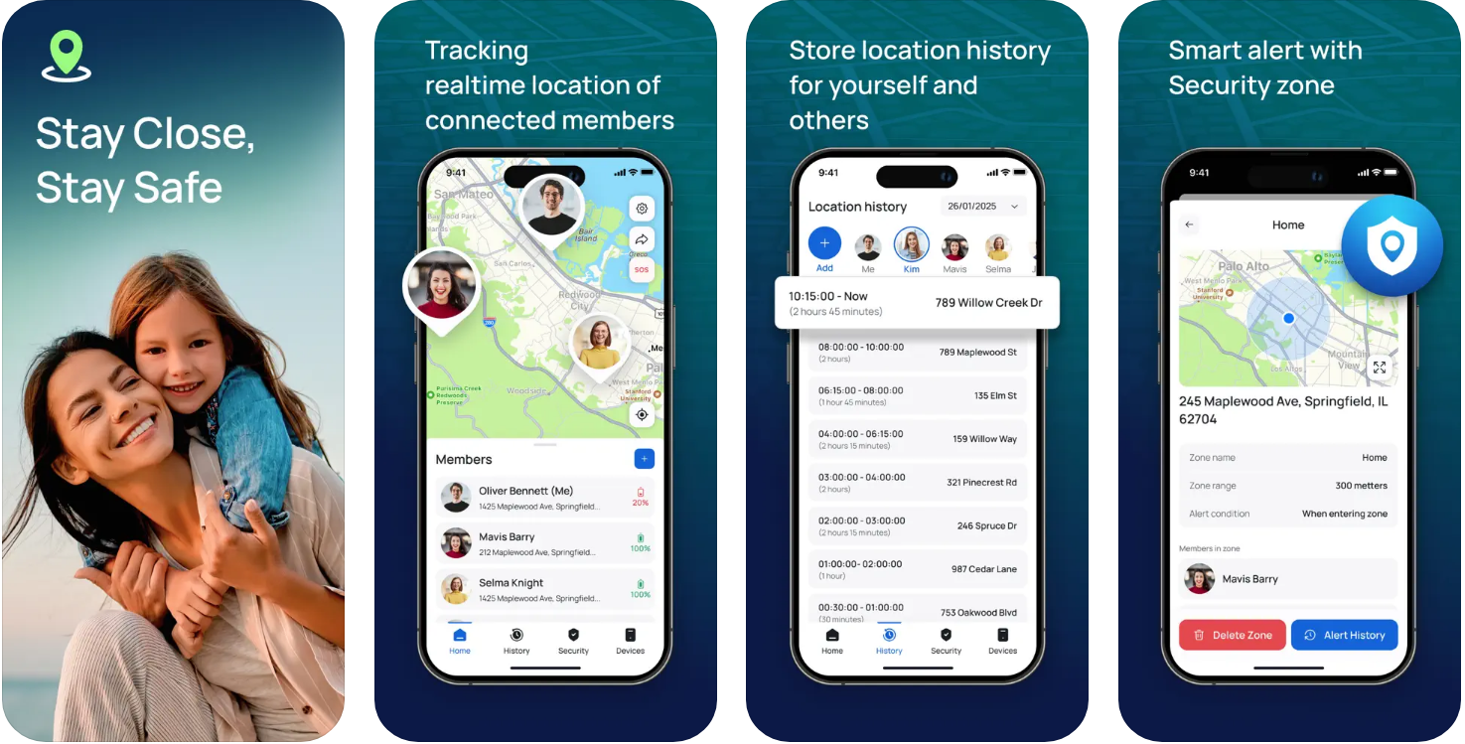
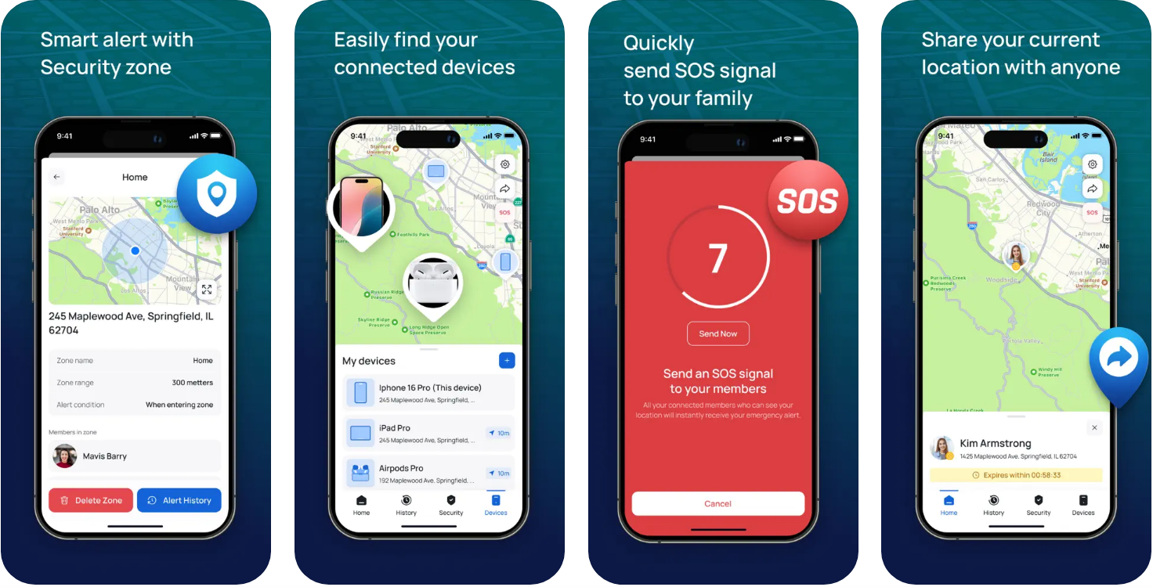

6. Conclusion
The Family Guardian project is a strong testament to DanaExperts' capabilities in providing top-tier outsourcing and technical consulting services. We successfully translated a concept into a tangible, high-quality product that met stringent technical standards and delivered significant business value to our client.
If you are seeking a trusted partner to bring your software ideas to life—from consultation to development and ongoing support—DanaExperts is committed to delivering optimized, efficient, and reliable solutions.

